COMMUNITY FOCUS North and Broadland
WEEKLY BULLETIN

Date: 27th March

Due to the current situation we are sharing some information which you might find helpful.

If you would like to update us on your own organisation, current operating capacity, contingency plans for your service users or any other information then please do contact us at:-
cs.cfoteam.nandb@norfolk.gov.uk

EARLY HELP HUB

The Collaboration Meetings at the Early Help Hub in Broadland District Council and Cromer District Council are cancelled until further notice.

Contact details if you need any support or advice:

North Norfolk:
Telephone: 01263 513811
Website: https://www.north-norfolk.gov.uk/contact-us/

Broadland:
Website: There is an online form at: https://www.broadland.gov.uk/broadlandhelphub
Telephone: 01508 533933

This bulletin has 3 main subsections:

- Advice and Guidance
- Support Services
- Volunteering
ADVICE AND GUIDANCE

Coronavirus - toolkit for professionals

We have created an online campaign page that will offer you some helpful coronavirus campaign materials as a local complement to the Public Health England and NHS advice on hand washing. The key message for this toolkit is about washing hands regularly, for 20 seconds, using soap and hot water.
We’re making these materials, which include social media images and posters, available to all our partners.
Please do make use of these on your own channels and share them with your staff. We will add additional information that may be useful to share with your staff and local communities as the situation develops.

https://www.norfolk.gov.uk/what-we-do-and-how-we-work/campaigns/coronavirus-toolkit-for-professionals

Coronavirus Advice

Latest information and advice can be found at: https://www.gov.uk/coronavirus

Public Health Matters
https://publichealthmatters.blog.gov.uk/2020/01/23/wuhan-novel-coronavirus-what-you-need-to-know/

Travel Advice
https://www.gov.uk/guidance/travel-advice-novel-coronavirus

Health Advice
For health information and advice, read NHS pages on https://www.nhs.uk/conditions/coronavirus-covid-19/

Coronavirus (COVID-19): guidance for health professionals and other organisations
https://www.gov.uk/government/collections/coronavirus-covid-19-list-of-guidance

Guidance for employees, employers and business
https://www.gov.uk/government/publications/guidance-to-employers-and-businesses-about-covid-19

Guidance for education settings
https://www.gov.uk/government/publications/guidance-to-educational-settings-about-covid-19/guidance-to-educational-settings-about-covid-19

Community Action Norfolk’s General Guidance for VCSE organisations
http://www.communityactionnorfolk.org.uk/sites/content/coronavirus-covid-19-guidance-organisations-0

Community Action Norfolk Advice for Community & Neighbourhood Responses to Covid -19
http://www.communityactionnorfolk.org.uk/sites/content/community-responses-covid-19-pandemic

Easy read leaflet, available in an electronic format through the Mencap website
https://www.mencap.org.uk/advice-and-support/health/coronavirus

NHS leaflet available to download from our Health information leaflet service website
https://brochure.norfolkslivingwell.org.uk/product/coronavirus-wash-your-hands-more-often-for-20-seconds-a4-poster

Tax Helpline to support small business and self-employed
https://www.gov.uk/government/news/tax-helpline-to-support-businesses-affected-by-coronavirus-covid-19

Warning: Scam awareness
Please be aware and notify others that there has been misuse of the British Red Cross brand by scammers as a way in to vulnerable communities.
British Red Cross are NOT utilising a postcard system currently in connection to Covid19 and any distribution of these cards locally needs to be reported to the authorities immediately.

Coronavirus Social Media Scams
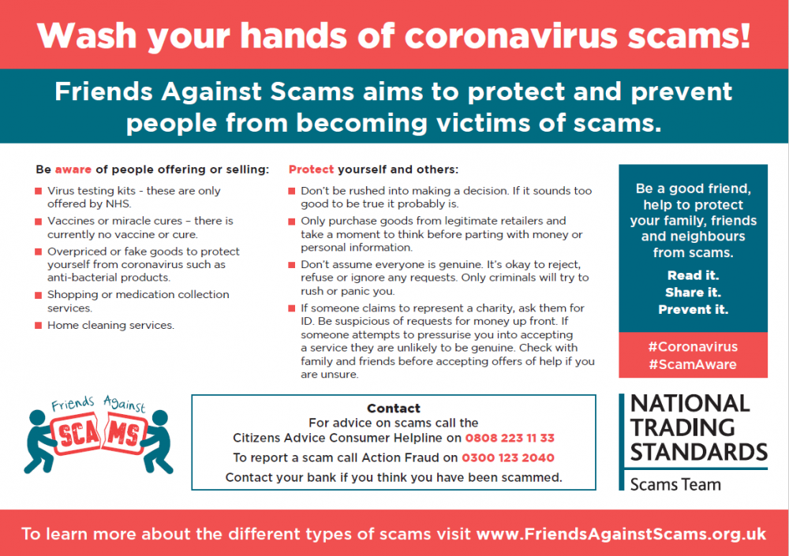 https://www.friendsagainstscams.org.uk/article/505/beware_of_covid_19_scams

The Friends Against Scams training has been updated to include further information on the types of coronavirus scams the team have seen and actions to take to protect yourself and others.
Scam awareness:
Below is a list of COVID-19 related scams compiled by Norfolk Trading Standards, you can sign up to receive scam alerts here.
- Be aware of people offering miracle cures or vaccines for coronavirus – there is no specific treatment for coronavirus (COVID-19). Treatment aims to relieve the symptoms until you recover.
- People impersonating healthcare workers, claiming to be offering ‘home-testing’ for coronavirus – this is a scam and these kits are not currently available to buy.
- Emails saying that you can get a refund on taxes, utilities or similar are usually bogus and they are just after your personal and bank details.
- There are lots of fake products available to buy online that say they can protect you or cure coronavirus. These will not help and are designed to take your money.
- There are new mobile phone applications that claim to give you updates on the virus but instead, they lock your phone and demand a ransom.
- Your bank or the police will never ask for your bank details over the phone.
- People offering to do your shopping or collecting medication and asking for money upfront and then disappearing.
SUPPORT SERVICES

FOODBANKS
 | Location | Time | Info
Monday
 | AYLSHAM  St Michael's Church  The Market Place  Aylsham  NR11 6EH | 9:30am-  11.00am
 | GORLESTON  The Well, Gorleston Baptist Church, Lowestoft Road, Gorleston, NR31 6LY | 9.30am- 12:00pm | Tel contact: 07786952306  Open for donations Mon & Thurs 9.00 – 11.30
 | GREAT YARMOUTH  Salvation Army, Tolhouse Street, Great Yarmouth, NR30 2SQ | 9:30am-  11:30am | Tel contact: 01493 858069  Open for donations Mon & Fri 9.00 – 11.30
 | NORWICH  Baptist Church, Witard Road, Norwich NR7 9XG | 2:00pm-3:30pm | Parcel collection only no home deliveries
Tuesday
 | AYLSHAM  Childrens Centre  The Pavillion, Sir Williams Lane  Aylsham  Norfolk NR11 6AW | 1:30pm-3:00pm
 | NORWICH  Oak Grove Chapel 70 Catton Grove Road Norwich NR3 3NT | 6:00pm-7:30pm | Parcel collection only no home deliveries
Wednesday
 | GORLESTON  The Bridge, St Mary Magdalene Church, Magdalen Square, Gorleston, NR31 7BZ | 9.30am- 11.30am | Tel contact: 07810 146853 Open for donations Mon to Fri 9am – 12 noon.
 | NORTH WALSHAM  Catholic Church of the Sacred Heart, Church Hall, Norwich Rd  North Walsham. NR28 9JP | 1:30pm-3:00pm
 | SHERINGHAM  Roman Catholic Church Hall  58 Cromer Road, Sheringham  NR26 8RT | 1:30pm-3:00pm
Thursday
 | CROMER  Methodist Church  Corner of West Street & Hall Road  Cromer  NR27 9DT | 1:30pm-3:00pm
 | FAKENHAM  Salvation Army 16 Oak Street  Fakenham  NR21 9DY | 11am-1pm | Parcel collection only no home deliveries
 | GORLESTON  The Well, Gorleston Baptist Church, Lowestoft Road, Gorleston, NR31 6LY | 9:30am-12:00pm | Tel contact: 07786952306  Open for donations Mon & Thurs 9.00 – 11.30
 | WROXHAM  Wroxham and Hoveton United reform Church,  114 Norwich Road, Wroxham, NR12 8SA | 10:30am- 12:00pm | Parcel collection only no home deliveries
Friday
 | GORLESTON  St Andrew's Church, Church Road, Gorleston, NR31 6LR | 2:15pm– 3:30pm | Tel contact: 07901 898438
 | GREAT YARMOUTH  Salvation Army, Tolhouse Street, Great Yarmouth, NR30 2SQ | 9:30am-  11:30am | Tel contact: 01493 858069  Open for donations Mon & Fri 9.00 – 11.30
 | HOLT  Holt Youth Project,  Old Station Way,  Holt, NR25 6DH | 1:30pm-  3:00pm
 | STALHAM  Stalham Baptist Church Stables  High St, Stalham, NR12 9AZ | 1:30pm-  3:00pm
Sunday
 | GORLESTON  St Andrew's Church, Church Road, Gorleston, NR31 6LR | 2:15pm– 3:30pm | Tel contact: 07901 898438
Mid Norfolk:
Email: info@midnorfolk.foodbank.org.uk
Website: https://midnorfolk.foodbank.org.uk
If you would like to donate food, currently, they need: tinned tomatoes, tinned meat, tea (small, non-speciality packs please), coffee, long life fruit juice, nappies (sizes 4-6)
Currently they have a good stock of: pasta, beans, tinned soup, and cereal

Cromer and District:

Tel: 07826 376343 (Monday to Friday 9am – 3pm)
Email: info@cromerdistrict.foodbank.org.uk
Website: www.cromerdistrict.foodbank.org.uk
The following items would be very welcome: Tinned Tomatoes, Tinned Fish, Tinned Potatoes, Pasta Sauce, Tea, Long Life Milk – Semi skimmed or Full fat, Instant Snacks – just add hot water, Sponge Pudding, Custard, Jam, Fruit Juice/Squash, Shampoo, Deodorant, Toilet Rolls, Children’s Toothbrushes and Toothpaste.
Currently they have a good stock of: soup and baked beans

Food banks

Please remember that vouchers should ONLY be issued for people in crisis that would have been anyway, not just because of the virus and due to them self-isolating; for example, please do not refer anyone who cannot get to the shops or where shops have run out of products and / or people who have finances available.

If you are aware of families that are self-isolating, there a growing number of community groups that are springing into action, and these may be able to help if there are no other family or friends that can assist. Details of these can be found at: https://covidmutualaid.org/local-groups/ click on the map to make it bigger so that you can hone in on your local area and see what support is already available. Also please encourage any groups that are being set up to register to this page, to ensure that help can reach as many people as possible.

Below are the details of the Trussell Trust food banks in the North Norfolk and Broadland areas. Please note that they do still need donations during this unprecedented time. Please see specific items that the food banks have advised that they are in need of, although obviously during this time all donations are very gratefully received.

Please also remember that there are also Community Fridges in some locations, but it would be a good idea to contact them before travelling to ensure that they are still open:

North Walsham: Located at Café Kitale. It is open Monday – Friday 10m – 2pm. https://www.facebook.com/pages/category/Community-Organization/North-Walsham-Community-Fridge-804113959940914/
Fakenham: Located at First Focus in Oak Street, Fakenham. http://www.firstfocus.org.uk/
Thorpe: Located at the Dussindale Centre. Telephone: 07717 362842

Norwich
Email: admin@norwich.foodbank.org.uk Website: www.norwichfoodbank.co.uk.
They are unable to deliver food parcels at this time - if someone cannot get out, someone else will need to get the voucher and collect it for them.
Stocks currently most needed are: Long life milk, Long life fruit juice, tinned vegetables, tinned meat, tinned fruit, long life sponge puddings and shower gel
Currently they have a good stock of: baked beans, cereal, pasta, soup and sanitary-wear

NCAN Strategic Partnership,

Notice on behalf of the NCAN Steering Group agencies (Age UK Norwich, Age UK Norfolk, Norfolk Citizen’s Advice, Diss and Thetford Citizens Advice, Equal Lives, MAP, Norfolk Community Law Service, Shelter)
In response to COVID-19 and in accordance with the Government’s recommendations we are reacting as appropriately as possible by taking seriously the health and wellbeing of staff, volunteers and the people who need our help.
We are adapting to this difficult situation and are continuing to work together in partnership to ensure that people can access quality information, advice, and specialist legal help. We are concerned about the social and financial impact this unprecedented situation will have on people’s lives, and that many will be pushed into or further into poverty. The full knock on effects are yet to be seen but we predict that there will be an increase in people needing advice and support due to a number of factors including loss of wages, increased debts, relationship breakdowns, potential evictions and homelessness.
Below is a summary of the current service provision from our individual organisations. If anything changes we will share as widely as possible.

Charity | Telephone | Email/Web Chat/Referral System | Face-to-face
Age UK Norwich | Advice line remains open: 01603 496333. | Referral System currently open.  enquiries@ageuknorwich.org.uk | Suspended.
Age UK Norfolk | Advice line remains open: 0300 500 1217.  Money Matters service will contacting each client to check needs. | Referral System currently open.  advice@ageuknorfolk.org.uk | Suspended.
Shelter | Advice line remains open: 03445151860. | Referral System currently open.  norfolk@shelter.org.uk | Office and face-to-face appointments suspended.
Equal Lives | Telephone line remains open: 01508491210 | Referral System currently open.  info@equallives.org.uk | Face to face appointment replaced with telephone appointments
MAP | Telephone line remains open: 01603 766994 | Referral System currently open.  info@map.uk.net | Telephone and on line support is offered. There will be a very small team at our Norwich office Monday to Friday 1.30-5.30. This will be for young people who can’t access us by phone or online and really need urgent help; things that absolutely can’t be done from home. They will speak to you by intercom and decide what to do.
Norfolk Community Law Service | Telephone line remains open and advice will be provided via telephone when possible: 01603 496623 | Referral System currently open.  info@ncls.co.uk | Suspended.
Norfolk Citizens Advice | Telephone line remains open: 03444111444 | Referral System currently open.  www.ncab.org.uk and click ‘email advice’.  Webchat available. | Suspended

Shopping for the Elderly, Vulnerable and NHS
(This is the most up to date version that we are aware of. Please see the individual store websites for further information as this is an evolving situation)
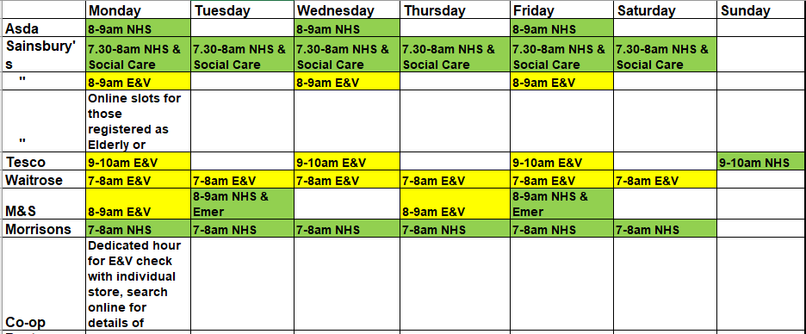

ASD Helping Hands
Norfolk Libraries
All of Norfolk’s libraries and library services have now been closed until further notice due to the Government’s guidance on coronavirus. This includes mobile libraries, the home library service, and Open Library.All borrowed items have been automatically renewed until further notice, and we are asking people to keep library books at home for the time being. Please be reassured that you will not be charged overdue fees, and any existing charges will not increase over time. This covers all items, including books, DVDs and music.
What library users can still do
Customers can download a range of free eBooks, newspapers and audio books, using their library card. People can also sign up to the Library Service online and receive a library card in the post. There will be Storytimes, Bounce and Rhyme and a range of other offers online during closure.
Free online books are available via the app, if you currently have a library card and pin.
- https://www.overdrive.com/apps/libby/
For more information go to: https://www.norfolk.gov.uk/libraries-local-history-and-archives/libraries/coronavirus-update

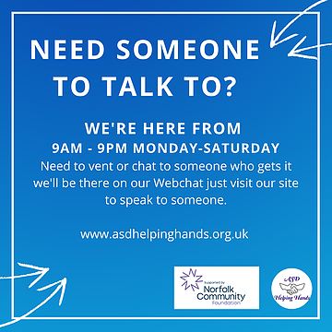

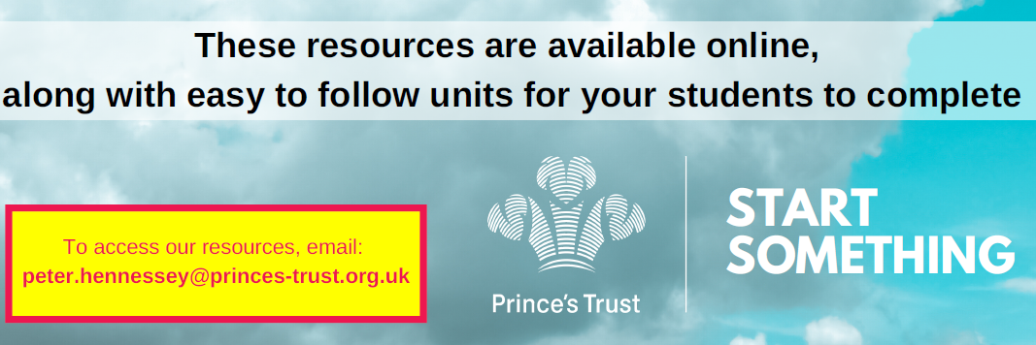
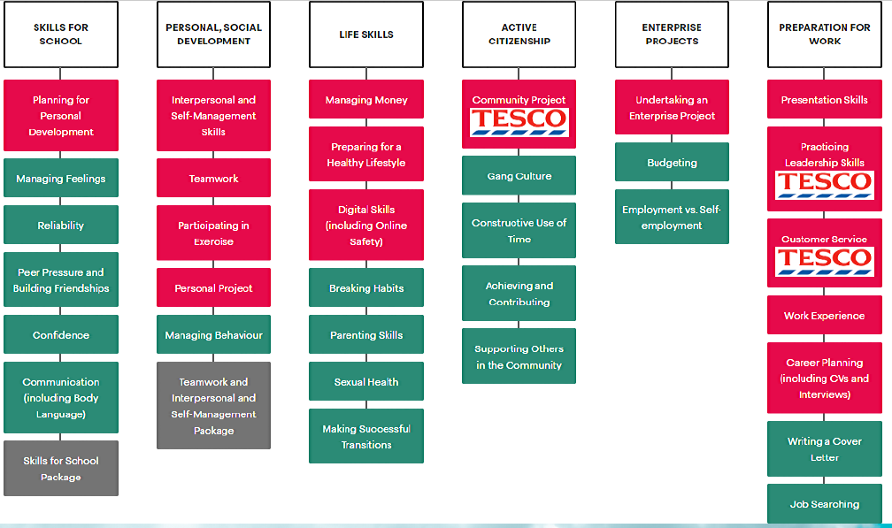
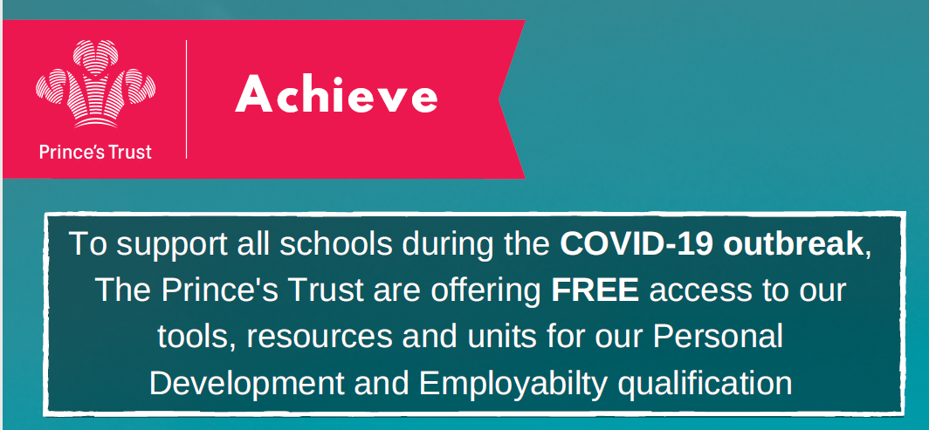

Short Breaks team update
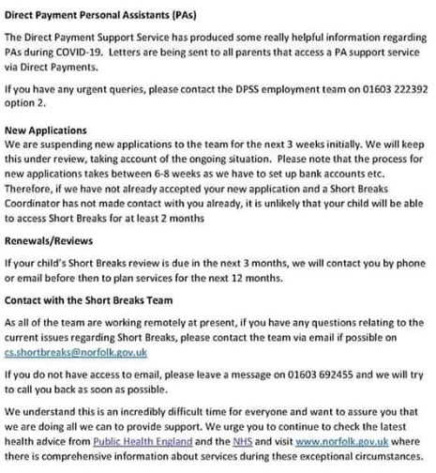

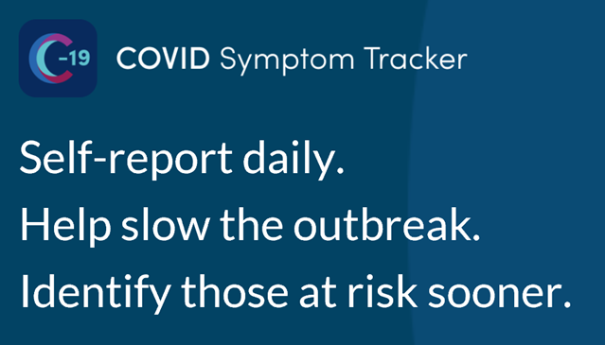

https://covid.joinzoe.com/
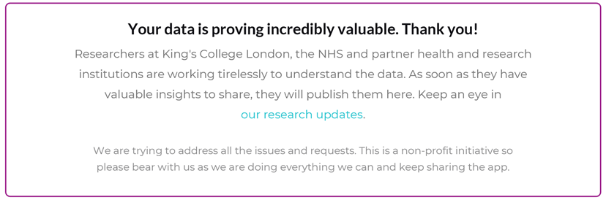
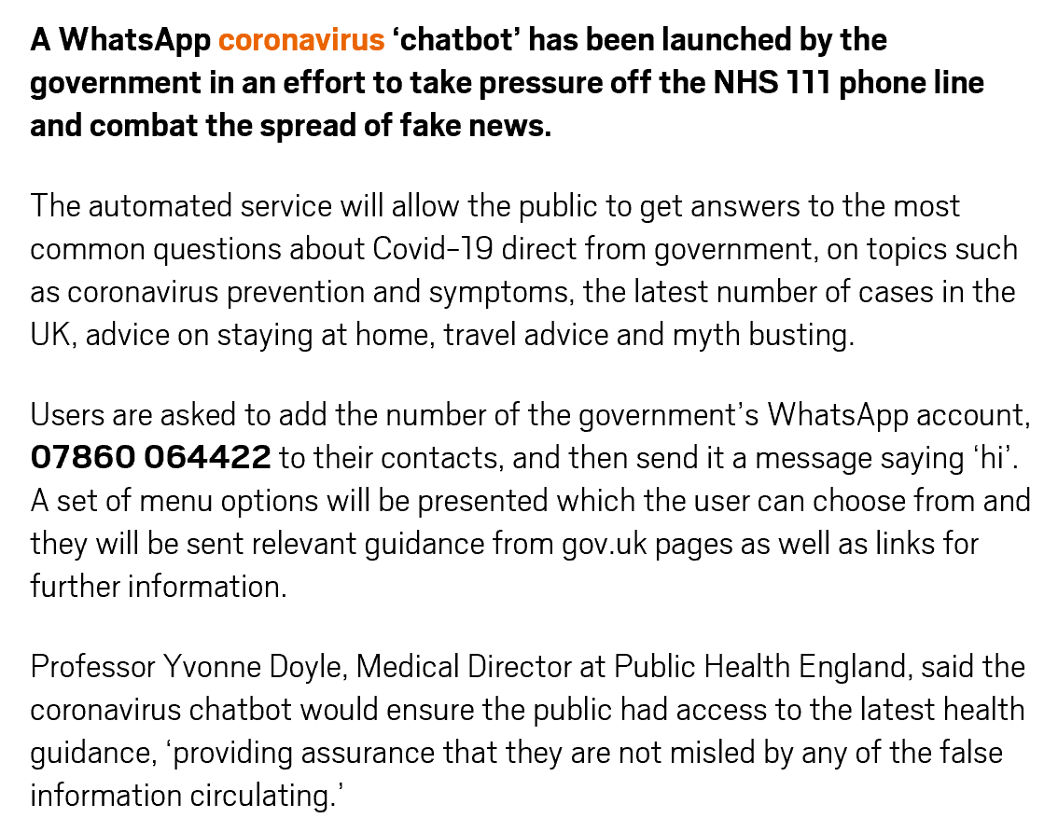

MIND - Supporting you to get active in the home and outdoors
At Mind we won’t give up until everyone experiencing a mental health problem gets support and respect. We use sport and physical activity to build resilience, to enable and support mental health recovery and to tackle stigma.
There are lots of resources available to help you to be more active in your home or outdoors in fun and creative ways. Here are some ideas, top tips and links to help support your physical and mental health whilst you are at home.

Ideas to help you to get started and stay active

- Active 10: A brisk daily walk is a great excuse to get outside and improve your health. The Active 10 app is a great way to help you monitor and gradually increase your brisk walking levels over time.
- NHS 10 minute workouts: Only got a few minutes? The 10-minute workout ideas are perfect if you've only got a bit of spare time when you're at home.
- Couch to 5k: This is a 9-week running programme designed for complete beginners by the NHS.
- Gym-free workouts: Going to the gym isn't for everyone. Luckily, there are plenty of other ways to get active instead. The NHS have created routines that you can do anywhere, anytime including seated exercises, strength, balance and flexibility sessions.
- Parasport : Parasport have created accessible home workouts that ideal for wheelchair users and those just getting started or haven’t been active for a while.
- Fitness Blender: - has over 500 free workout videos enabling you to choose the level of difficulty depending on whether you are new to exercise or looking for something more advanced.
- Yoga with Adriene:- Yoga instructor Adriene offers over 500 free YouTube videos supporting you to get started through to adaptations for the more advanced.

Activities to take part in as a family:
- Youth Sport Trust: have a range of YouTube videos with fun challenges and activities that can be adapted to the space you have available.
- Disney dance alongs: This Girl Can have partnered with Disney to provide dance work outs, you can learn their moves or put your own spin on their routines.
- Change4life Indoor activities: Shake Up games inspired by your kids' favourite Disney characters.

Tips for individuals:

- Take part in fun challenges online/offline or create your own, examples include
- “Get Active” bingo
- how many “sit-to stands”, “step ups” or other activities you can do in a minute
- set yourself a challenge over a time period for example walk or run a marathon over a month
-complete the A-Z of activity – how many different activities can you come up with
- Involve other people by doing them together over a video call or via a virtual event
- Make space to get outdoors whenever you can, if you have a private outdoor space.
- It doesn’t have to be long or intense – moving more is the key and finding something fun

Resource from Young Minds aimed at children and young people who are anxious about the virus:
https://youngminds.org.uk/blog/what-to-do-if-you-re-anxious-about-coronavirus/

Resource from Mind aimed at adults who are anxious about the virus: https://www.mind.org.uk/information-support/coronavirus-and-your-wellbeing/

VOLUNTEERS
Volunteer to support the Coronavirus (Covid-19) response
Voluntary Norfolk, Momentum and Community Action Norfolk are working with Norfolk County Council and local health providers to recruit volunteers for a county wide effort to respond to the Coronavirus (Covid-19 crisis. We are particularly keen to hear from people who have the skills to volunteer in health and social care roles, which have been identified as priority areas.
- When you register, tick the COVID-19 (Coronavirus) Call for Volunteers box, as your Area of Interest.
- You only need to complete the mandatory fields, but please make sure you include your phone number.
- After you submit your details, you will receive a call back in due course from a member of our Covid-19 Volunteering Response Team to discuss what you can offer, what volunteers are needed in your local area and the next steps. Please be aware that this may take a bit of time as we coordinate our efforts with our partners
- You may also be contacted by a VCSE organisation directly if they think you would be a good fit for their Covid-19 volunteering role.
https://www.voluntarynorfolk.org.uk/home-2/volunteering-2/register-to-volunteer-2/

If you would like to offer support to vulnerable neighbours, family or friends, this postcard can be printed, filled in and passed to them.

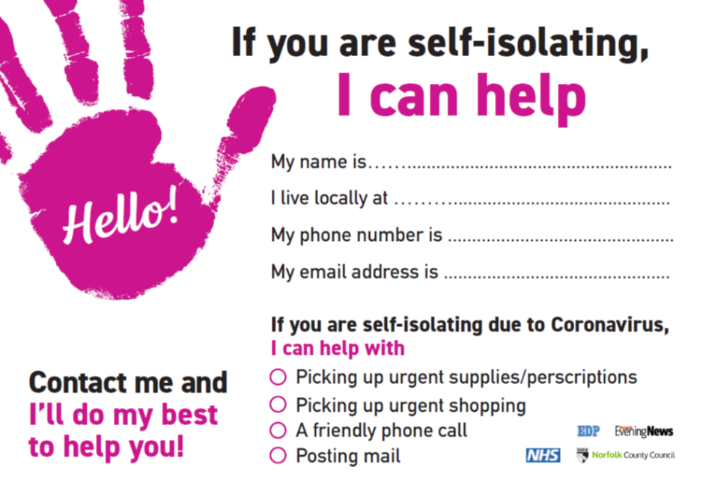

Community Action Norfolk

Help for emerging groups
“We are seeing numerous community initiatives emerge in response to the Covid-19 pandemic. This is a fantastic statement on the caring nature of our communities. For basic advice and information go to our webpage ‘Community Responses to Covid-19 Pandemic’
By adapting guidelines and policies used to develop CAN’s existing Good Neighbour Schemes (GNS), we are able to offer emerging community groups the opportunity to be a Good Neighbour Response Team, where all your volunteers will be signed up under CAN’s Insurance and structures. We will also be able to provide you with information and guidance in relation to a wide range of practicalities including safeguarding, data protection and volunteer management. So if you have started or are thinking of starting a group and would like to be part of our Good Neighbour Response get in touch by emailing covid@communityactionnorfolk.org.uk
Working with other partners, we are coordinating support to help people running or developing community groups so do email us with your questions and support requests on covid@communityactionnorfolk.org.uk”

Funding for Covid-19 community groups

Norfolk Community Foundation, through its Covid-19 Community Response Fund Covid-19 Response Fund, is offering grants of up to £1,000 to support community action to help vulnerable people affected by the Covid-19 outbreak. It aims to make funding decisions as quickly as possible on a rolling basis while the fund is open. The continued availability of these grants is dependent on the progress of the fundraising appeal working alongside.

The information provided in our bulletins is sent to us from various sources. We try to ensure the information is correct at the time of publication but there may be some inadvertent errors. Publication in our bulletin does not necessarily constitute an endorsement of a service / organisation and we would advise you to take reasonable steps to check the services offered and organisation prior to using them – especially if you are referring children, young people and vulnerable adults to a service. Norfolk County Council cannot accept any liability for any services provided by a third party.

